**CREATING A YOUTUBE V3 API KEY**

1. Log in to ANY gmail account
2. In order to Register an application follow the steps below
3. Go to the developer console in another browser tab

<https://console.developers.google.com/project>

1. Create a Project – click on create project / new project

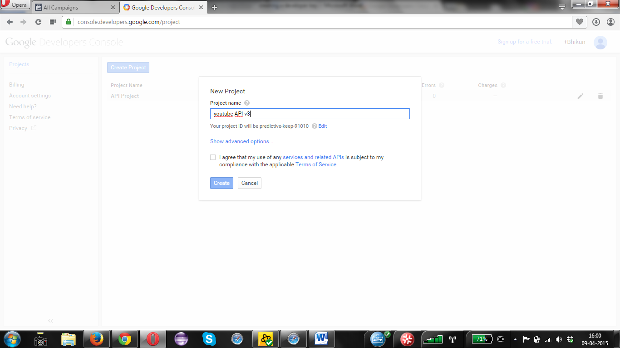

1. Once the project is created, click on the project name. The you need to click on Enable an API button

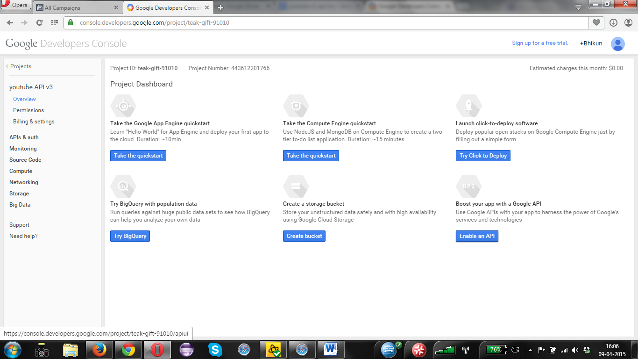

1. You need to enable youtube DATA API (below youtube API)
2. Now you need to enable the youtube API, click on Enable API

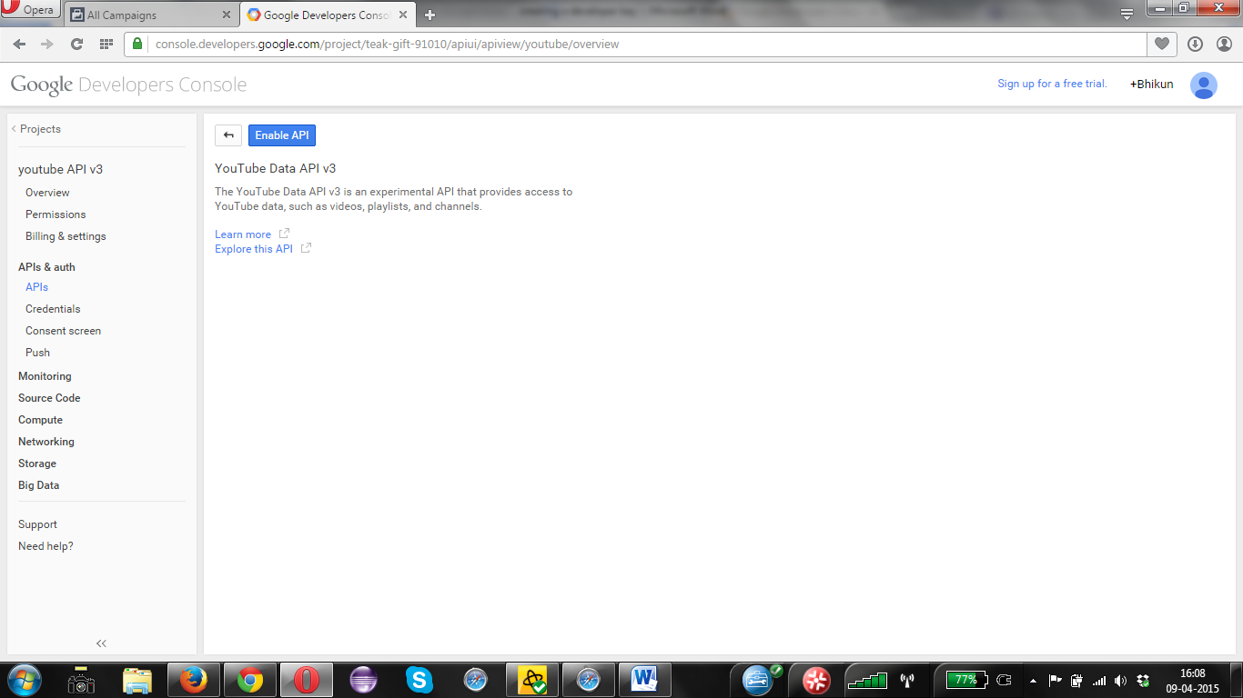

1. Once you have enabled Click on the “Credentials” under “API’s and Auth” on left hand side of the page.

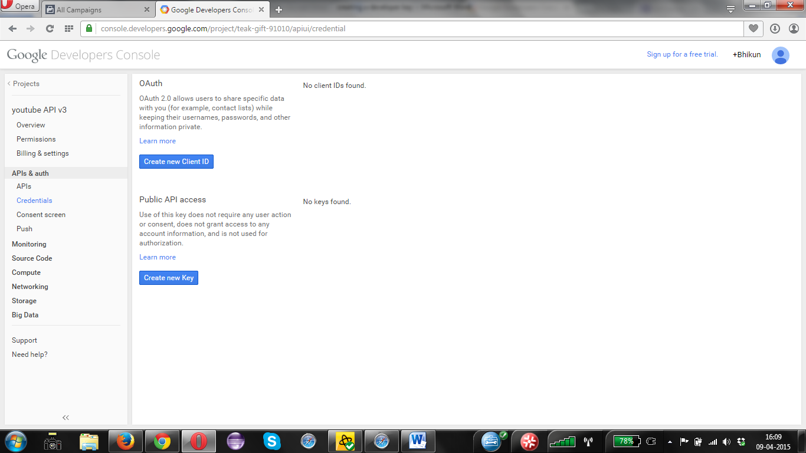

1. Click on Create new Key

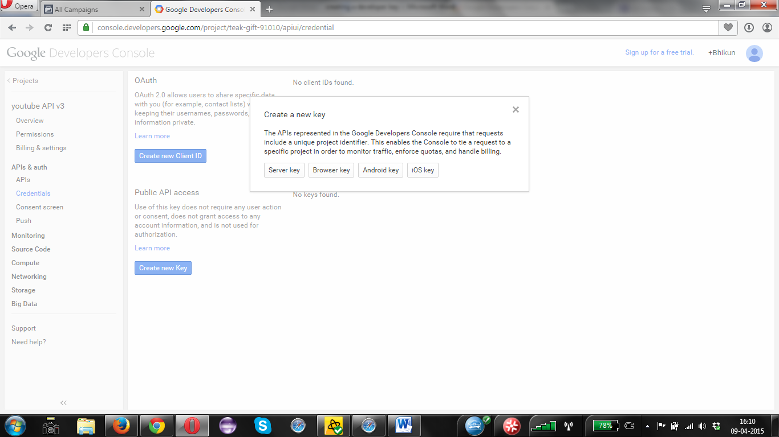

1. Click on to create **Browser Key and in the open box add do not add anything and click on create**

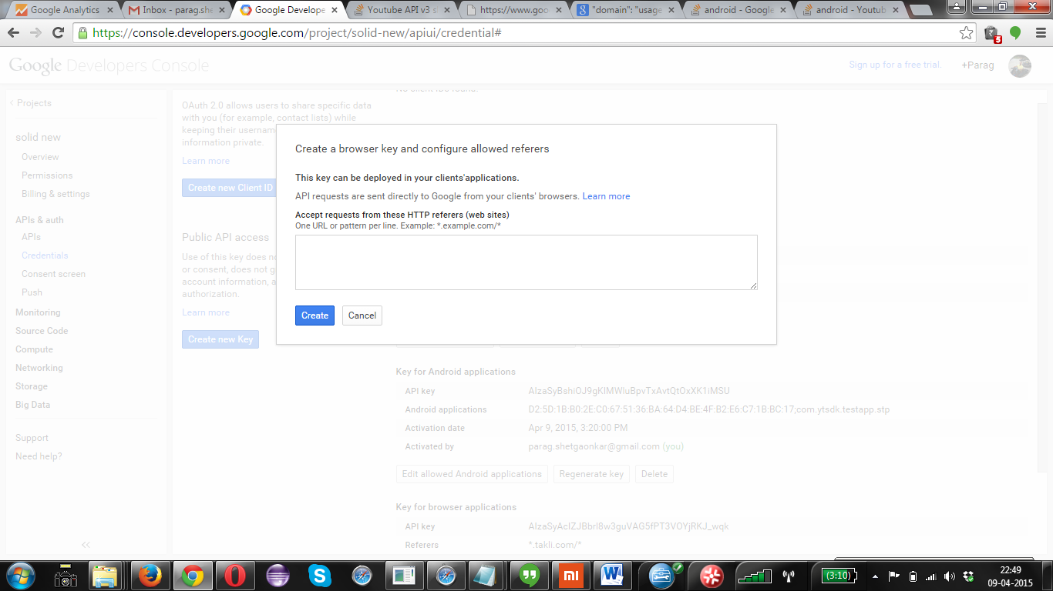

1. You will get the KEY.

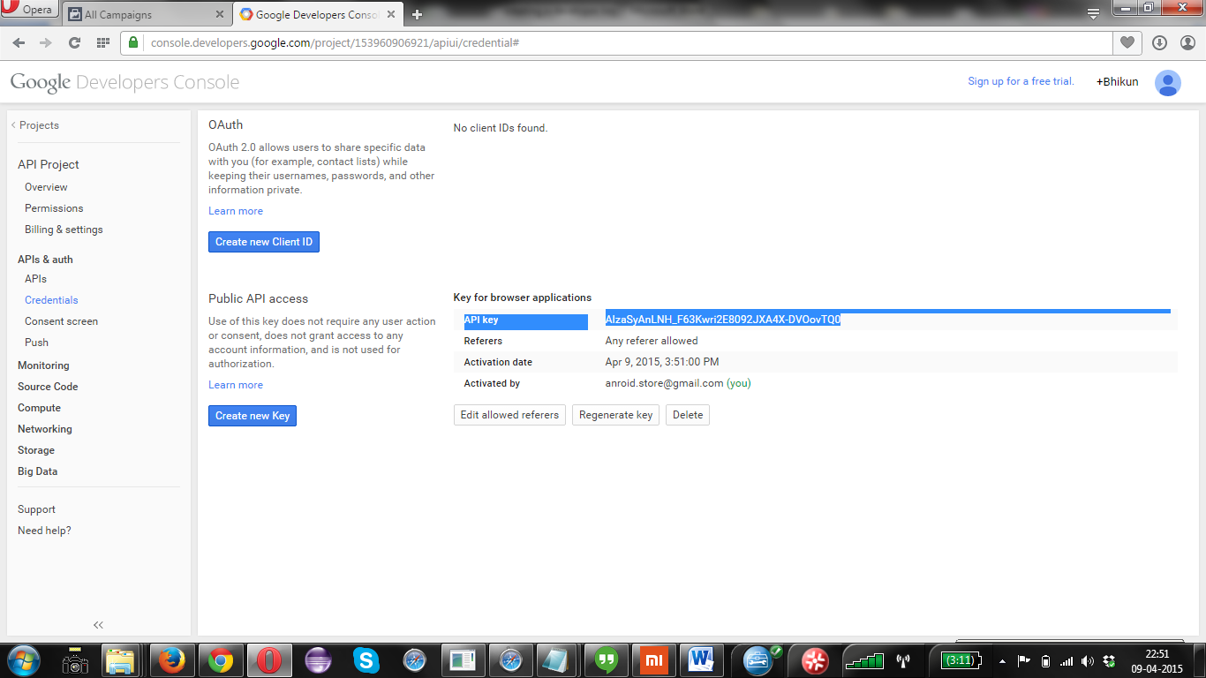

**Use that key in your application.**

Support email: [ytsdk.help@gmail.com](mailto:ytsdk.help@gmail.com)

You can view this video, the video is shown with old UI so don’t get confused <https://www.youtube.com/watch?v=Im69kzhpR3I>